BUOYANT FLAKE OCEAN FERTILISATION (BFOF)

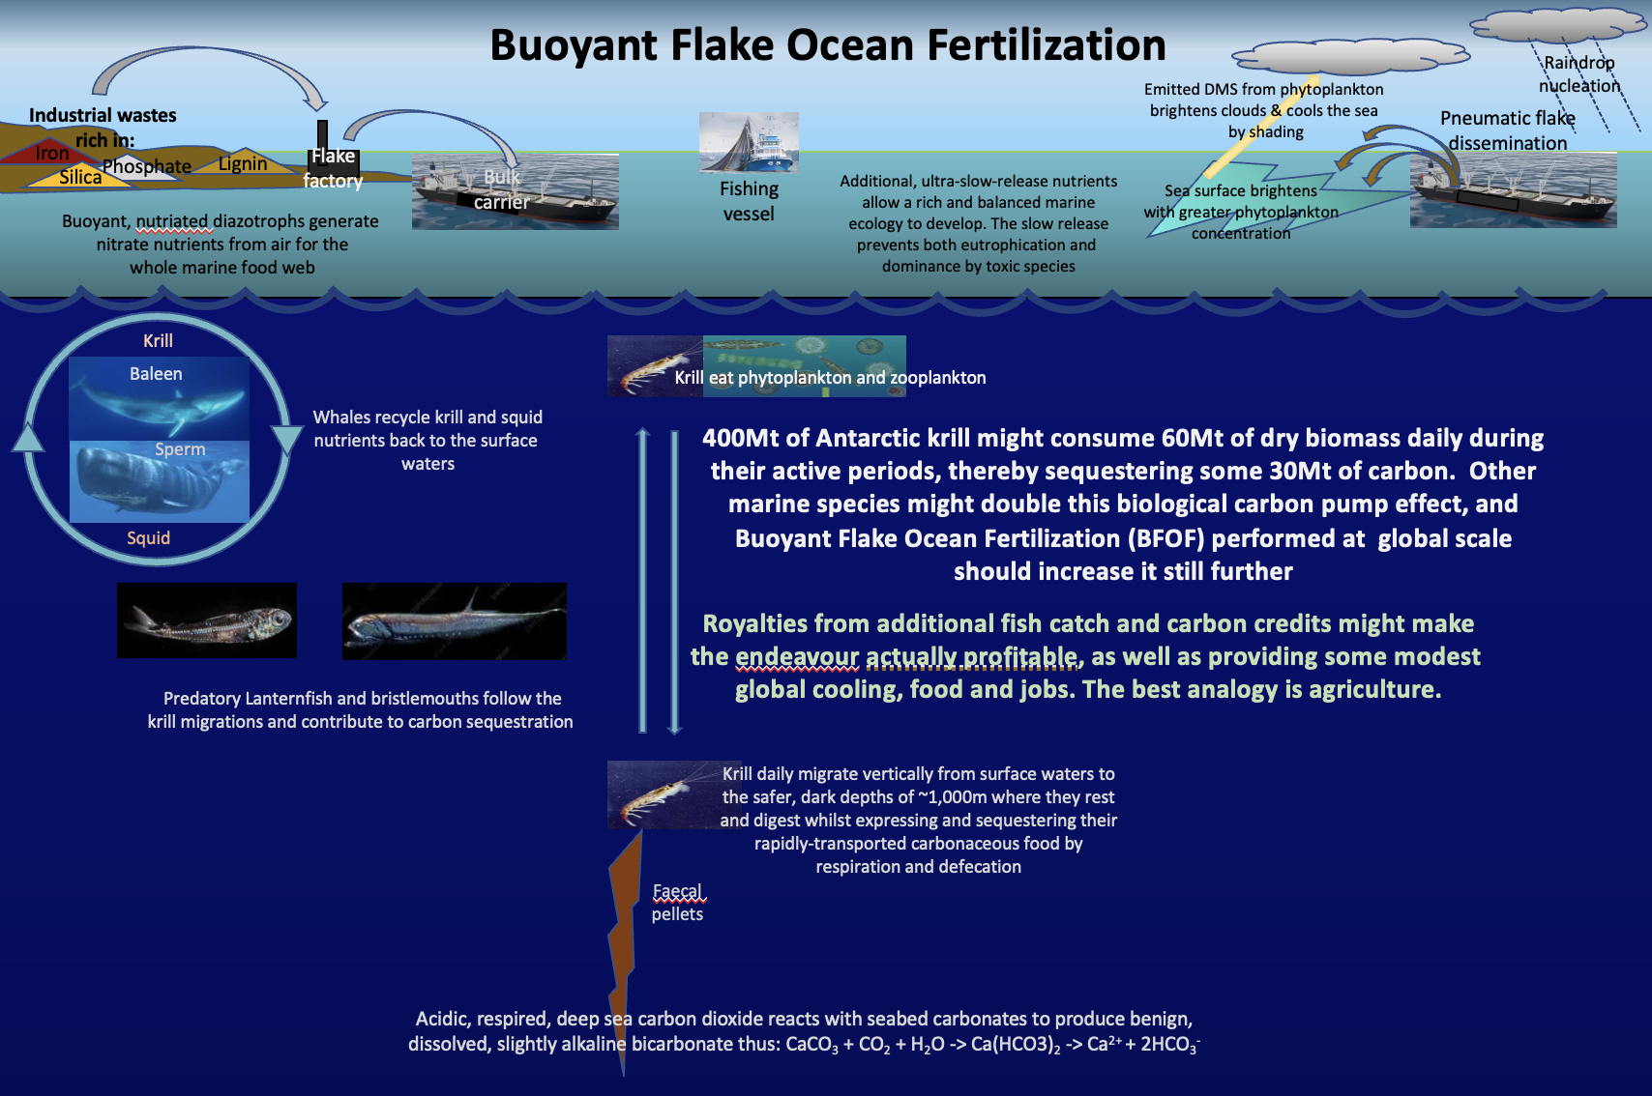

Short Description
Previous attempts to farm the sea or to increase oceanic carbon sequestration have used soluble, artificial chemicals that do not remain near the surface. However, long-lived, ultra-slow-release buoyant flakes can be disseminated annually by ship over selected ocean areas. The tiny flakes are comprised of natural, organic materials and mineral wastes. Like a self-feed system, these do not so much release the nutrients to the environment, as to make them available at the sunlit sea surface where the phytoplankton which need them can ’suck’ them out of the exposed mineral particles in the flakes using their transporter enzymes or ligands. Thus, there is little chance of either over-fertilisation, eutrophication, toxicity, or of the nutrients being lost rapidly to the dark depths. The foundation of each flake is a single rice husk, rich in the opaline silica needed by diatoms. Glued to this by plant-derived lignin hot-melt glue is a sealed matrix of air and minerals designed to provide phytoplankton communities with whatever nutrients are wanting in that part of the ocean. As dark blue ocean waters are deficient in one or more macronutrients or trace elements (typically phosphate, iron, silica and transition metals - reactive nitrogen nutrient being able to be made from air by cyanobacteria), using buoyant flakes could turn these blue or ‘desert’ ocean regions into productive, turquoise seas. Krill and most other diel vertically migrating (DVM) species consume much phytoplankton in surface waters at night, then respire and excrete the carbonaceous wastes in the dark, safe depths of up to a kilometre deep during daylight hours, thereby sequestering its carbon content.

Deployed at global scale, the albedo enhancing effect of the additional phytoplankton should be more than sufficient to offset the current level of global warming – provided too many other tipping points are not passed before flakes are deployed widely.

Key Functions
Increases the biomass and biodiversity of marine life; sequesters atmospheric carbon dioxide (CO₂) securely as carbonaceous seabed ooze & rock, refractory dissolved organic carbon (DOC), and benign, dissolved, alkaline bicarbonate; increases oceanic albedo (reflectiveness) that cools the surface waters; increases atmospheric DMS aerosols that nucleate or brighten cooling marine clouds.
Innovation Dependencies
None known

