**A CONCEPTUAL METHOD TO MEASURE MARINE CARBON DIOXIDE REMOVAL (CDR)**

*Sev Clarke, May 2022*

**Introduction**

Methods reliably to measure long term carbon sequestration, its duration and risk profile are often difficult, costly, or near impossible to determine. The problems may worsen when the carbon sinks in question are complex and difficult to access. The ocean is one such sink, though with its different forms of sequestration is one of the largest and safest. Two forms are particularly noteworthy: dissolved bicarbonate and seabed ooze that can eventually form limestone and fossil fuels. These are the carbon sinks that are particularly targeted by the Buoyant Flakes Ocean Fertilisation (BFOF) method. What follows is a hypothesis, confirmation of which should make it much easier to measure, report and verify its effects.

**Krill Pump Hypothesis**

The marine Biological Carbon Pump (BCP) is regarded as being key to ocean carbon sequestration. However, its long-term effectiveness is said to be reduced by perhaps two orders of magnitude because of the diminution caused by microbial action on the organic fraction of marine snow as it slowly sinks through the euphotic zone. Recently, the extent of this diminution has been challenged because of the discovery that diel vertically migrating (DVM) species, in particular krill (but also probably including copepods, lanternfish, bristlemouths and squid) tend to consume phytoplankton in surface waters at night, but return to the darker, safer depths during daylight hours where the respire and defecate most of the carbonaceous material that had been captured in surface waters by photosynthesising phytoplankton and their zooplankton predators. As krill tend to rest during daylight hours at depths of approximately a kilometre, this means that the carbonaceous material they express there will tend to remain in the deep ocean for centuries.

Fairly recent measurements indicate that there are some 379Mt of Antarctic krill *(Euphausia superba)* biomass in the Southern Ocean, with other krill species distributed over the global ocean in smaller masses. Lanternfish (600Mt) and bristlemouths are reported to be amongst the most prevalent fish species in the ocean, see also <https://www.nature.com/articles/ncomms4271> . Now, the cold, dark ocean depths are possibly the best place to sequester atmospheric carbon, and Antarctic krill may be the best organism to transport it there. Should each Antarctic krill, in its active time, daily transport a gut content of just 15% of its body mass, this means that 0.15x379Mt = 57Mt/day of (assuming wet) biomass with perhaps a 20% carbon content might sequester 11MtC/day. Other DVM species would add to this; and BFOF deployed yearly over the >80% of ocean that can be regarded as oligotrophic (nutrient deficient, or with an average sea-surface chlorophyll of, say, <0.5mg chl m-3 would add much more, see

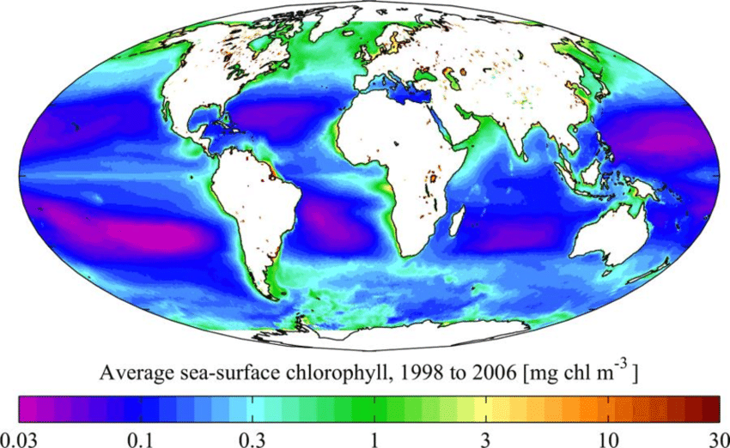

**How To Measure**

As Antarctic krill are likely to have the principle, but by no means the only, CDR effect of BFOF use, we can focus on just them. Sonar is probably the way by which their total biomass has been estimated. Hence, if two scientific vessels were each to make the same summertime circumpolar voyage at different latitudes around Antarctica at the same time, measuring the krill biomass at the same set of points, and recording the late night gut content of near-surface sampled krill, using something like the krill capture device we have designed, then with previous depth-sampled gut contents and body mass measures, a good and reliable measure of the biosequestration achieved by Antarctic krill should be obtained and which can then be compared against previous years, some of which would be without BFOF enhancement. To cope with continental and thick, sea-ice lateral irregularities, provided that each vessel kept to the same yearly route, their latitudes could be made to vary to suit the topography and the current location of productive krill pastures. However, as krill habitat increased as a result of BFOF, a third surveillance vessel might be required at lower latitude.

Once the method had been tested, improved and UNFCCC-approved, organisations purchasing the licence to fertilise with BFOF a given, moving plume of Southern Ocean water would win the carbon credits and other fishing rights therefrom. High seas areas not having such good sequestration potential might only offer the fishing rights. Thus, with a standard, approved method of long-term CDR measurement, achievable with current resources, the Southern Ocean and where Antarctic krill can be made to flourish (estimated to be the larger region of the Antarctic Convergence Zone where cold waters meet warmer ones) should become available for economical CDR.