Biological Control of Arctic Methane Emissions

**William S. Clarke**

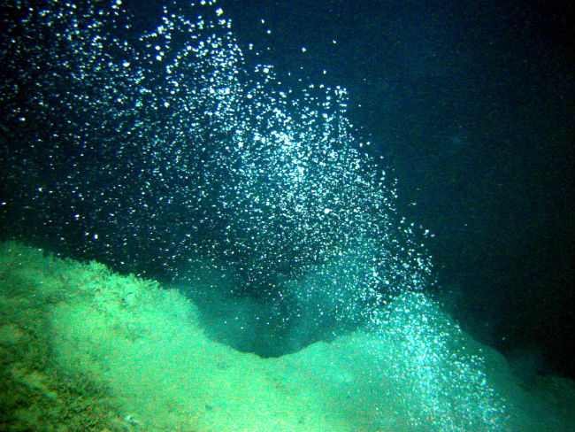

*Image: Methane bubbles from: Sauter et al. dx.doi.org/10.1016/j.epsl.2006.01.041*

As the Arctic Ocean seabed, tundra, and the frozen methane clathrates they contain warm, increasingly large clouds of methane bubbles have been observed ascending in pools and seawater. If these cannot be contained or converted, they are likely to cause catastrophic global warming within the expected lifetime of our children.

Reducing our carbon dioxide and methane emissions dramatically is no longer sufficient to avoid this from happening. Our two best chances are either to have the issuing methane captured and converted into something more benign, or to cool the Arctic quickly. Both appear to be daunting tasks. However, both may still be feasible. This paper focuses upon using biological means to convert the issuing methane into biomass.

Methanotrophic (methane eating) bacteria can do this using one of two metabolic pathways, aerobic or anaerobic. The aerobic route oxidises methane into methanol or formaldehyde that is then transformed into biomass. In the anaerobic route typically used by bacteria resident in ocean sediments, consortia of archaea and nitrite- or sulphate-reducing bacteria produce both biomass and carbon dioxide from methane (source: Wikipedia ‘Methanotroph’). Both routes use enzymes that contain essential metal atoms that are typically in short supply there. The metals include tungsten, copper, nickel, cobalt and molybdenum (Glass et al. 2013).

It is proposed that there be modelling, and subsequent testing, to establish optimal parameters for buoyant flakes carrying slow-release minerals that provide a balanced ‘diet’ of these essential metals, to allow the methanotrophs to proliferate and consume most of the newly emitted methane, before it can cause excessive global warming. Where a targeted site does not contain sufficient sulphate for the sulphate-reducing bacteria, cheap and plentiful calcium sulphate (gypsum) may be added to the powdered mineral mix.

Biological solutions typically have three major advantages. First, they are a natural form of control. Second, they modulate themselves to the extent of the problem. And third, they are typically both economical and fast-acting.

It is surmised that methanotrophs cannot metabolise methane when it is in frozen form in clathrates. Similarly, the methanotrophs in water, sediment, or soil must be in intimate, and preferably prolonged, contact with their gaseous or dissolved methane food source in order for them to be able to metabolise it effectively. This is not the case when the methane has been given time to aggregate into large bubbles or to issue directly into the atmosphere via vents, fissures or eruptions. It is therefore important that the metals be sufficiently available to methanotrophs both continuously and along the entire and diverse pathways of their emission and pre-atmospheric movement. Hence, the minerals should preferably: permeate the entire water column (albeit at low concentration); be present in at least the upper layers of sediments and soils; coat the surfaces of fissures and vents; and lie on the sea ice, tundra or swamp surface, ready to be elevated to a commanding position with the water surface. The surface may be either that of the sea, or of puddles, ponds, lakes and streams that form from rainfall or from thawing ice and permafrost.

The minerals should also be able to be economically distributed to all these environments. Small, benign and buoyant flakes can do this best, as they are readily disseminated pneumatically from ship or plane, with acceptable evenness and cost, to the most inaccessible areas. As the flakes slowly release their mineral payloads into the water, dissolution, assimilation and mineral particle sinking take the needed enzymatic metals to where the methanotrophs are present and can metabolise them so that they can proliferate enough to consume the varying amounts of emitted methane.

The buoyant flakes may be formed from a suitable mixture of low-grade mineral powders and the powdered lignin ‘thermoplastic glue’ left over from the extraction of sugars from straw or woody waste that glues the mineral mix in layers, and with tiny voids, onto cereal husks. These three materials have typically been regarded as waste products, or ones of little or no commercial value – though new uses are being found for lignin. All can be regarded as renewable resources. All are available in more than sufficient quantity to fertilise the Arctic many times over. It is surmised that the flakes will last approximately a year on the ocean surface, and possibly much longer in soil and sediment.

Most of the nutrients from the flakes will presumably enter the biosphere, where they will typically recycle many times before becoming buried deep in sediment, along with the lignin. Of course, some of this newly laid down, organically-rich sediment will be re-metabolised into methane or carbon dioxide. However, these in turn will readily be converted back into biomass by the aforesaid processes.

Methanotrophic action is most effective when it operates on methane that is either dissolved in the water column, or when the bubbles are very small and hence have a large surface area to volume that allows good mass exchange between the gas, the water and the methanotrophs. Furthermore, the smaller are the bubbles, the slower the rate of their ascent and the more readily are they able to attach and entrain methanotrophs to them. In consequence, the slower the rate of their ascent means that there is a longer period in which the methanotrophs can extract and metabolise the methane into biomass before the bubble bursts at the surface, releasing the methane to the atmosphere. The generation of tiny bubbles from slowly melting clathrate is also important as nano- and microbubbles typically do not have the buoyancy to free themselves from their solid attachment. Hence, they may stay attached for long periods, thereby providing greater opportunity for local methanotrophs to consume them even before they commence their ascent or coalescence with other bubbles.

The flakes disseminated over the Arctic Ocean may also incorporate other lacking nutrients necessary for the growth of phytoplankton, such as iron, silica and phosphate. These will have the additional benefit of cooling the Arctic by increasing its albedo (reflectiveness) by ocean surface and marine cloud brightening. The increase in phytoplankton concentrations may be necessary to ensure that any additional carbon dioxide resulting from predation upon the methanotrophs, or that from other causes of methane oxidation, is also converted into benign biomass.